**WREG Improvements Wish List**

Michael S. Kohn

January 14, 2016

1. Convert WREG into an exploratory tool with a solver to identify the best one-, two-, three-variable equations, and so on. Currently, there is an OLS R-script that is the exploratory tool and then WLS and GLS equations are built based of the OLS results.
2. Be able to use WREG to generate plots and tables that compare potential explanatory variables with each other and with the dependent variable which are building the regression equation for such as peak flow. Currently these plots are generated in R or excel.
3. Be able to reduce the number of input files for GLS analysis to less than 6. Currently the following files are needed:

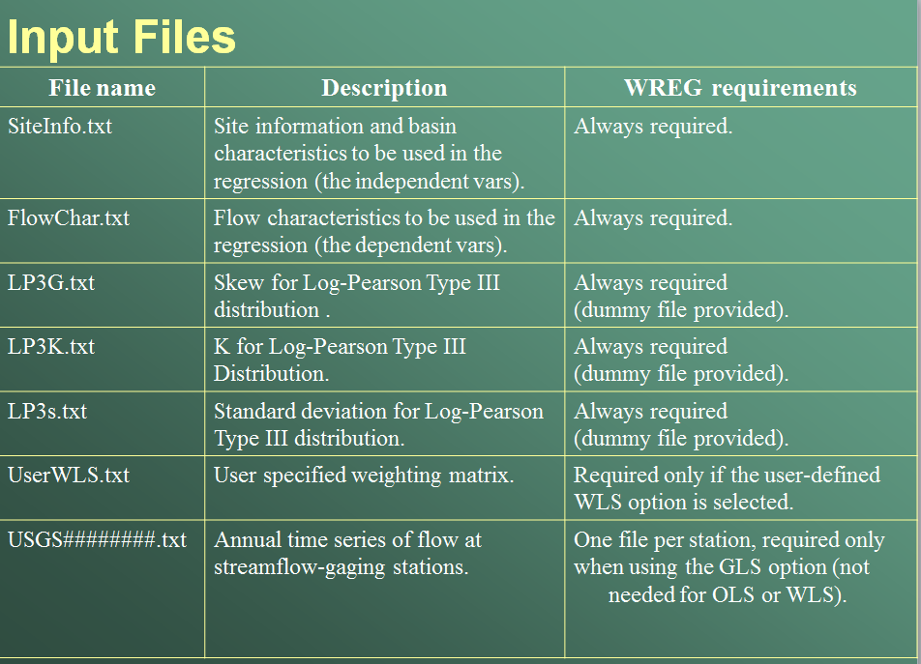

This is an example PeakFQ output file (.EXP files) and the highlighted data are parsed to create the input files for WREG (listed above).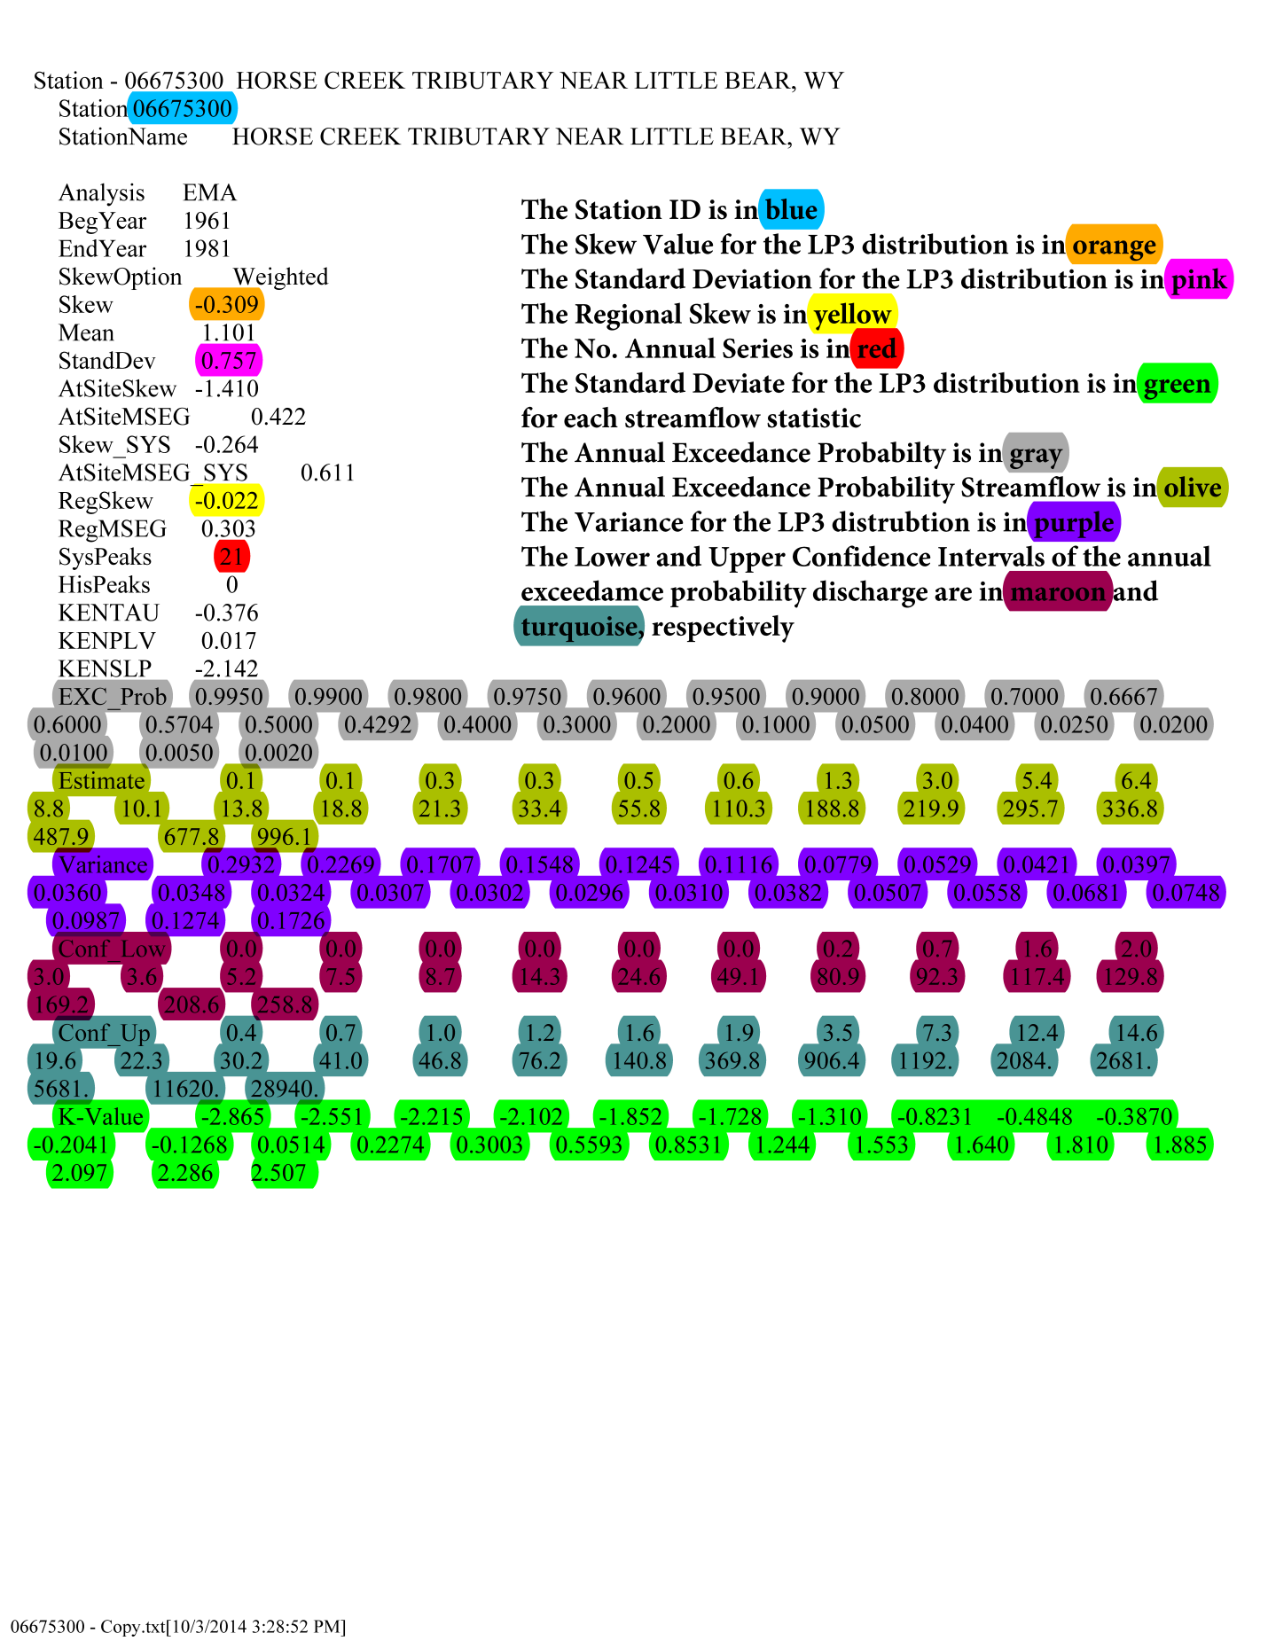

1. Be able to edit the gages in WREG to remove or change files that are in the analysis without having to change all 6 files text files above individually to change which gages are used in the analysis.
2. It would be helpful to generate multiple equations at the same time, for example once the explanatory variables are set, generate the equations for the 50-, 100-, 200-year flow, and so on with one model run.
3. Be able to generate a USGS publication quality figure or table with all the equations presented in the report (created in the previous section) so that it can be included into a report with little additional editing. Can this file also be generated in adobe illustrator or word for easing editing at the SPN? See example:

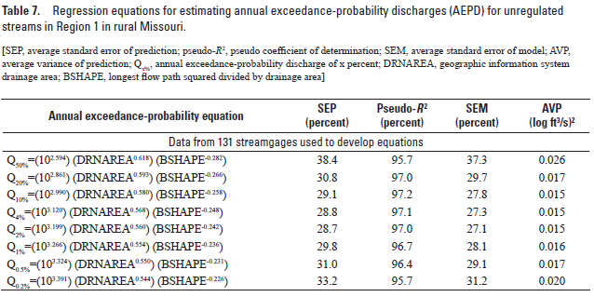

1. Be able to generate a USGS publication quality figures or tables to display the following results since these products are typically found in most statistical hydrology reports and are strongly encouraged by Andrea Veilleux in my experience but are all made “by hand” outside of WREG. I would talk to Andrea and see what figures and tables she would encourage including in a typical flood frequency report and see if these could be generated automatically since the data for whatever Andrea suggests is already in WREG. Can these file also be generated in adobe illustrator for easing editing at the SPN?
   1. A table of all explanatory variables tested for potential use in equations
   2. A table of AEPDs (annual exceedance probability discharge) from PeakFQ for all recurrence intervals.
   3. Range of explanatory variables used to develop AEPD equations.
   4. Predicted versus observed discharge for various AEDPs.
   5. Regional exponents and constants determined from regional regression of log-transformed drainage area for area-weighting method to estimate annual AEPDs for ungaged sites on gaged streams.
   6. The explanatory variable (drainage area) or variables versus the dependent variable (streamflow).
   7. Residuals for each explanatory variable used to generate the equation.
   8. Plots of the explanatory variables against each other.
   9. A table of the weighted AEPDs estimates, the variance of prediction values derived from the applicable PSRREs, the PeakFQ AEPDs, the variance of prediction values for the all the streamgages included in this study, and the peak flow estimate from the PSRREs.
   10. The values of *t*(*α/2,n-p*) and *U* needed to determine prediction intervals for estimates obtained by the regression equations.
2. Create a new Techniques and Methods documenting the new WREG.
3. Discuss with the StreamStats group to see if they have suggestions that could improve things from their perspective.